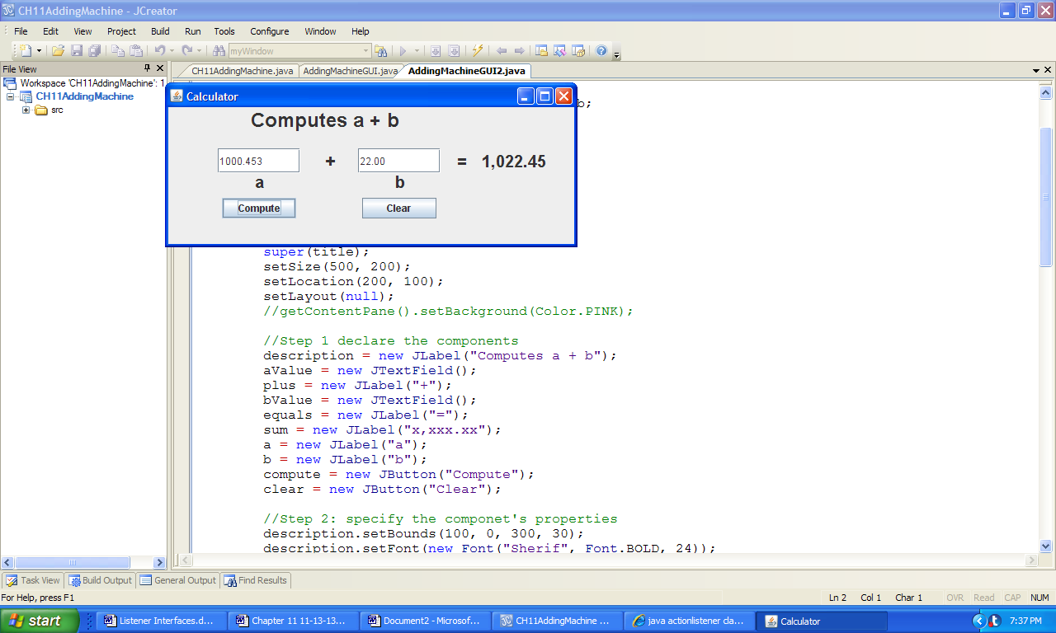 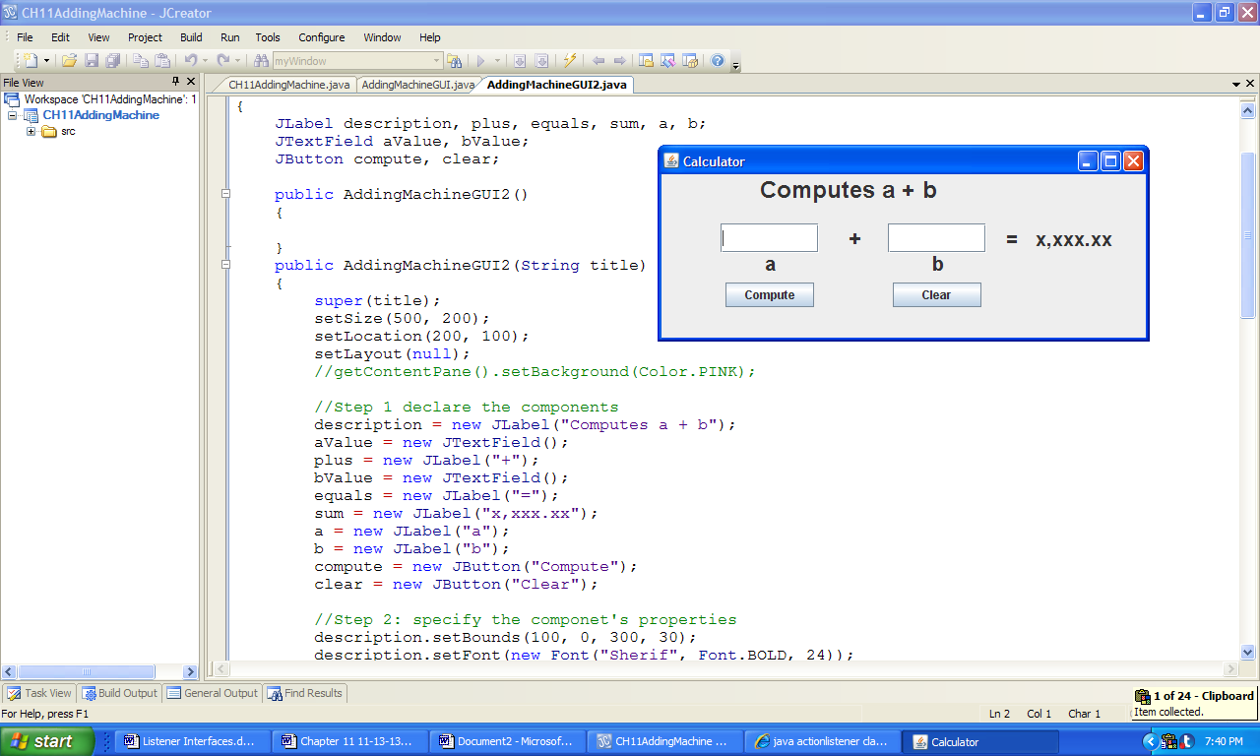

a) b)

**Figure 11.20 Output generated by the class AddingMachineGUIV2's Compute and Clear buttons.**